Superstore Sales & Profit Analysis
Exploratory data analysis using Tableau
Submitted by :
P. Likitha
Internship Name:
Virtual Tableau Visualization Intern
Task:
Week-1- Exploratory data analysis
Tool:
Tableau
Date:

Introduction:
Exploratory Data Analysis (EDA) is the process of examining and understanding a dataset using statistical summaries and visualizations. It helps identify trends, patterns, relationships, and unusual values in the data.
In this project, the Superstore dataset was analyzed using Tableau to understand sales and profit performance. Different visualizations were created to examine sales trends, category-wise performance, regional performance, sub-category profitability, and the relationship between discount and profit.
The main objective of this analysis is to transform raw business data into meaningful insights that can support better decision-making.
Objectives:
• To explore the Superstore sales dataset.
• To analyse sales and profit performance.
• To identify trends over time.
• To compare different categories and regions.
• To examine the relationship between discount and profit.
• To identify highly profitable and loss-making sub-categories.
• To create an interactive Tableau dashboard

Dataset Description:
The Superstore dataset is a retail sales dataset containing information about orders, customers, products, sales, discounts, profits, shipping, categories, and geographical regions. The Orders sheet was used as the primary dataset for this analysis.
Variable | Description
Order ID | Unique order identifier
Order Date | Date of order
Customer Name | Customer name
Segment | Customer segment
Region | Geographical region
Category | Product category
Sub-Category | Product sub-category
Sales | Sales amount
Quantity | Quantity sold
Discount | Discount applied
Profit | Profit generated

Tools used:
• Tableau – Data analysis and visualization
• Microsoft Excel – Dataset
• Microsoft Word – Report preparation

Data Visualization

Sales by Category

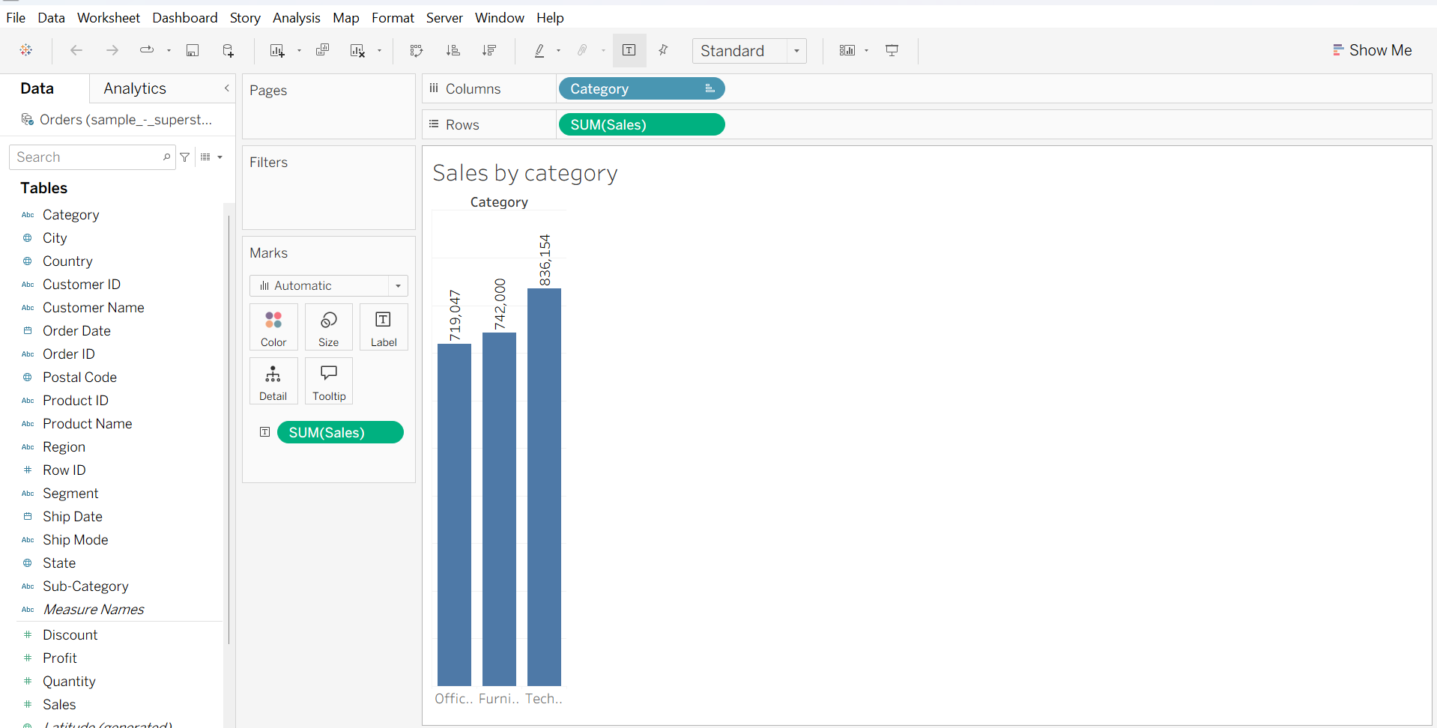
Purpose: Compare sales across product categories.
Insight: The chart helps identify which product category contributes most to overall sales.

Sales Trend Over Time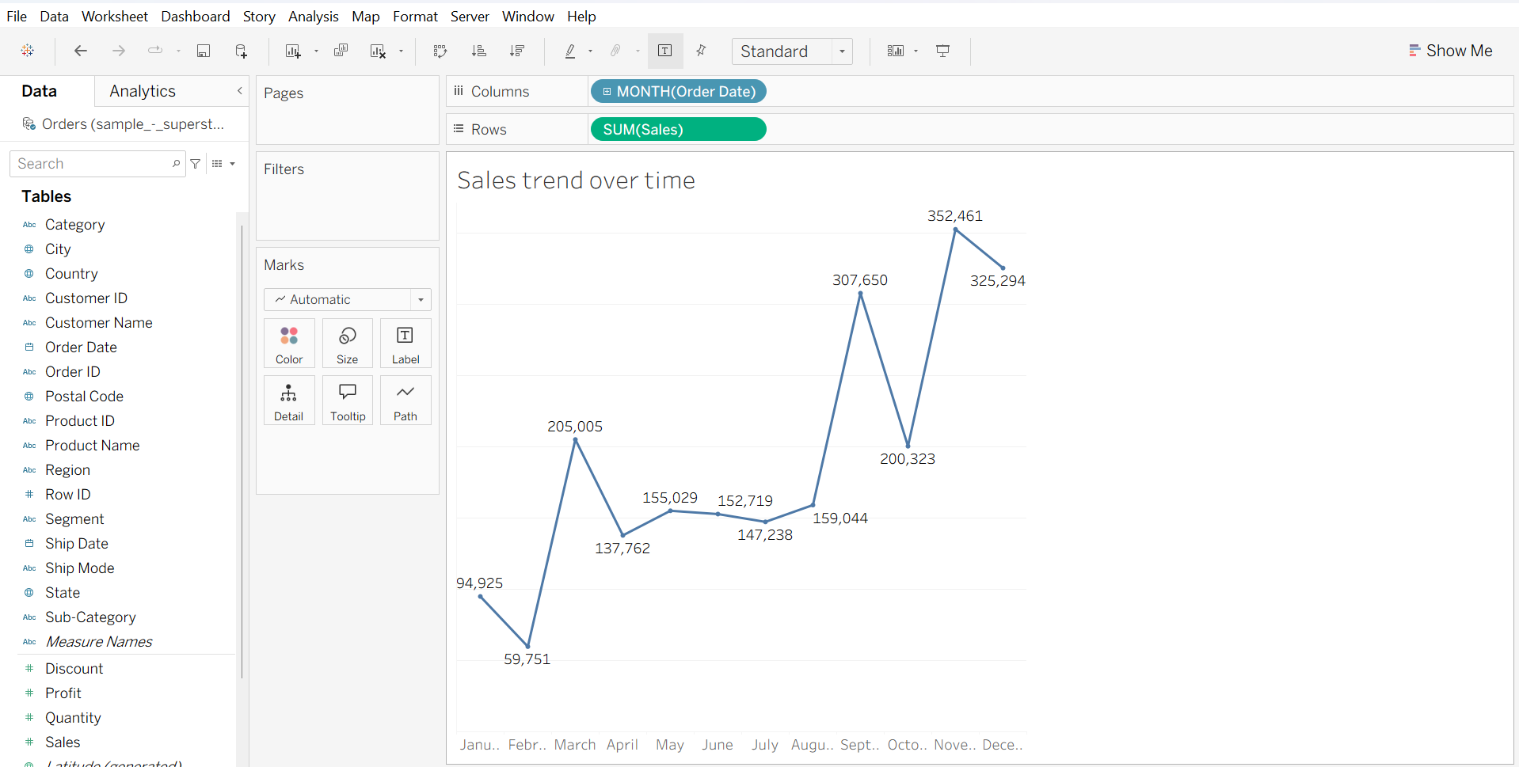
Purpose: Analyze changes in sales over time.
Insight: The visualization shows fluctuations in sales across different time periods and helps identify periods of stronger or weaker performance.

Profit by Category
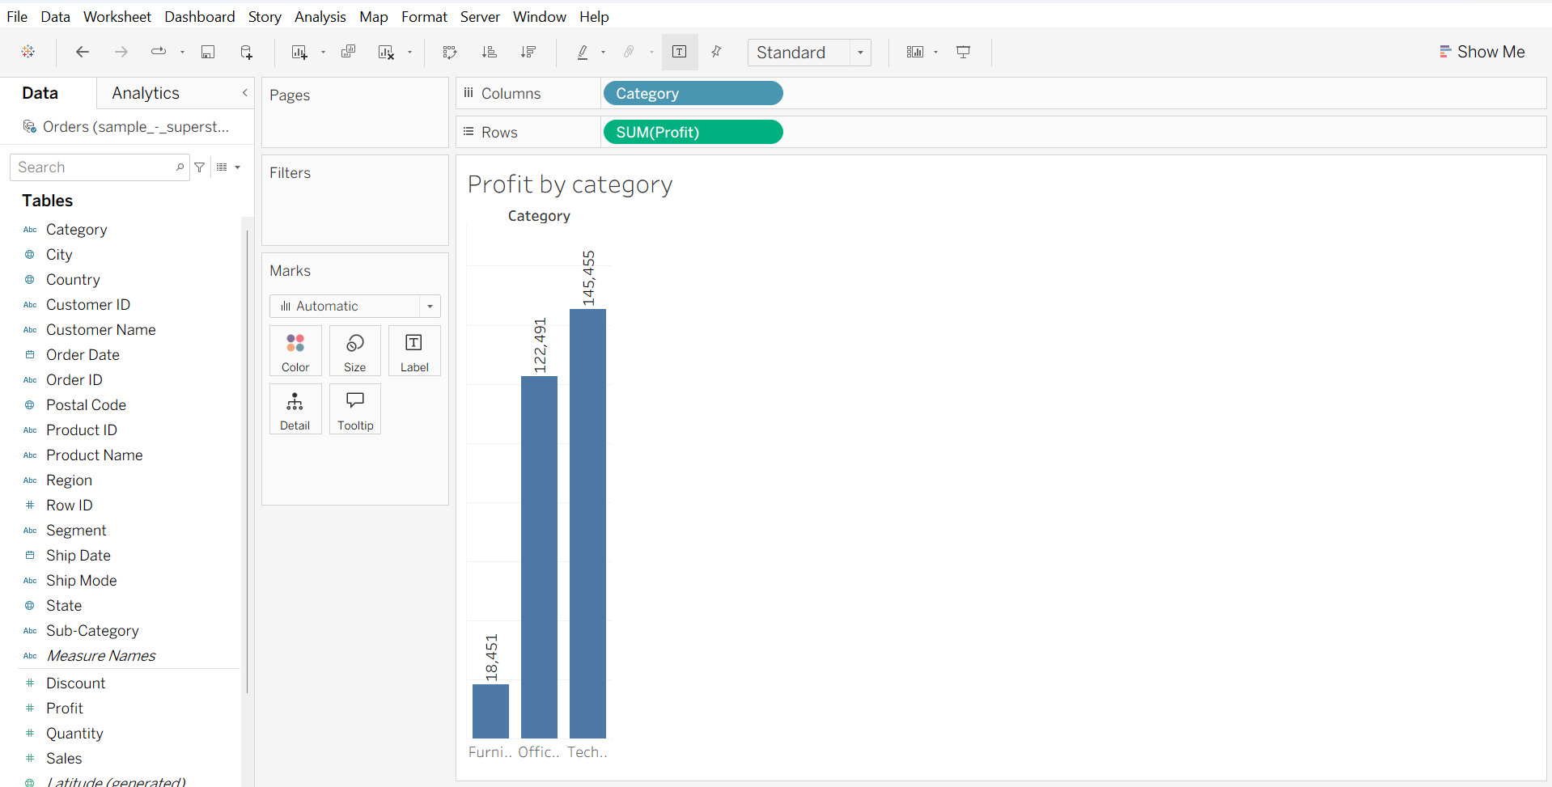
Purpose: Compare profitability across categories.
Insight: The chart shows differences in profit contribution among the product categories.

Sales by Region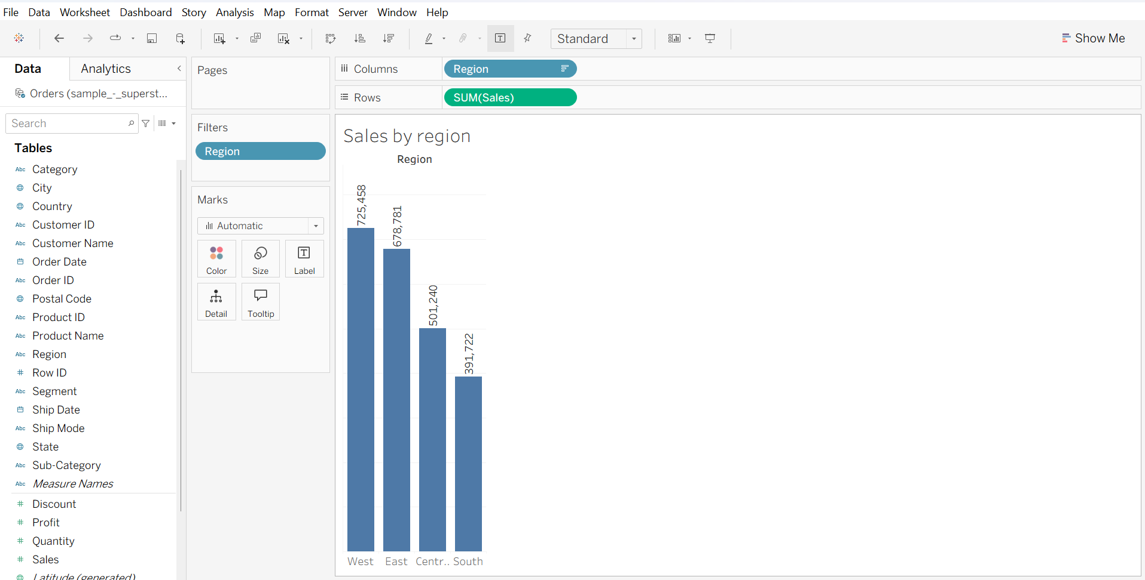
Insight: Sales performance varies across the four regions, allowing stronger and weaker regional markets to be identified.

Profit by Sub-Category
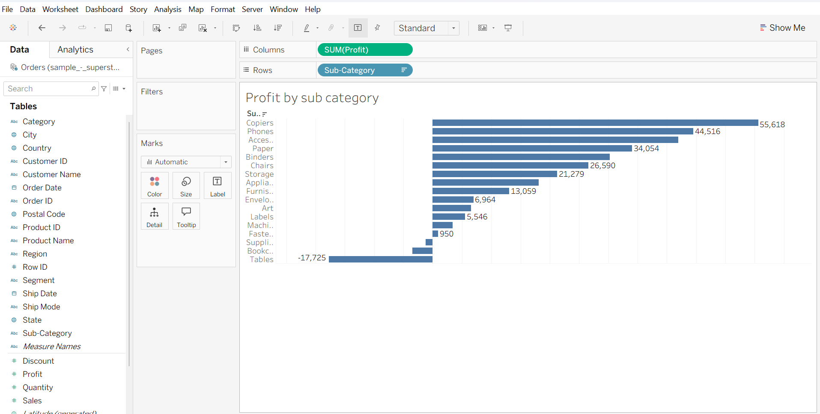
Key findings:
- Copiers have the highest profit, approximately 55.6K.
- Phones generate approximately 44.5K profit.
- Tables show the largest negative profit, approximately −17.7K.
- Bookcases also show negative profit.

Discount vs Profit:

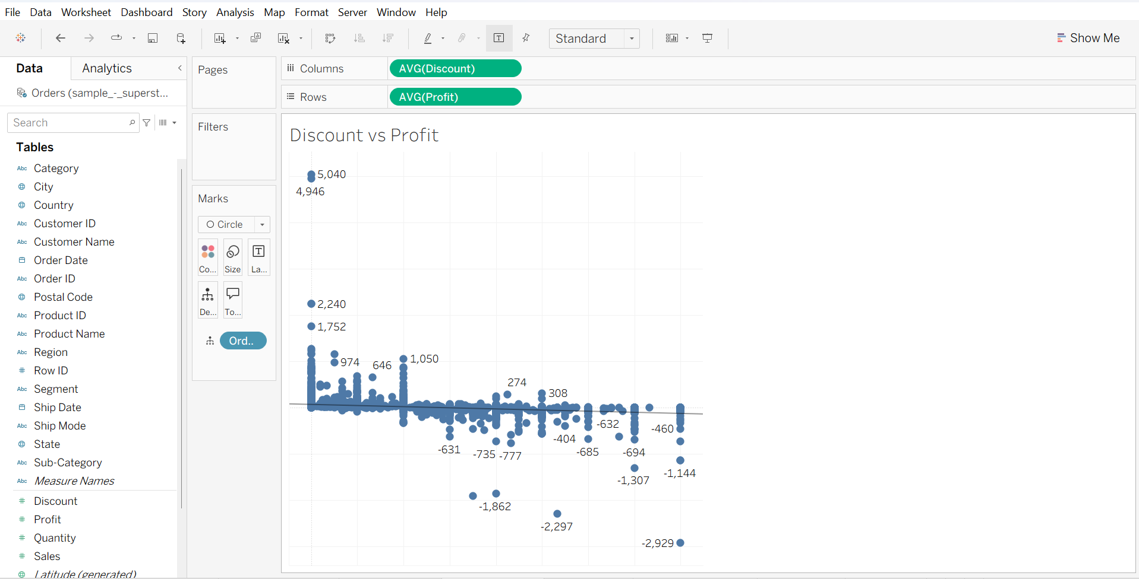
Insight: Higher discount levels generally show an association with lower profit, with several high-discount observations having negative profit.

Tableau Dashboard
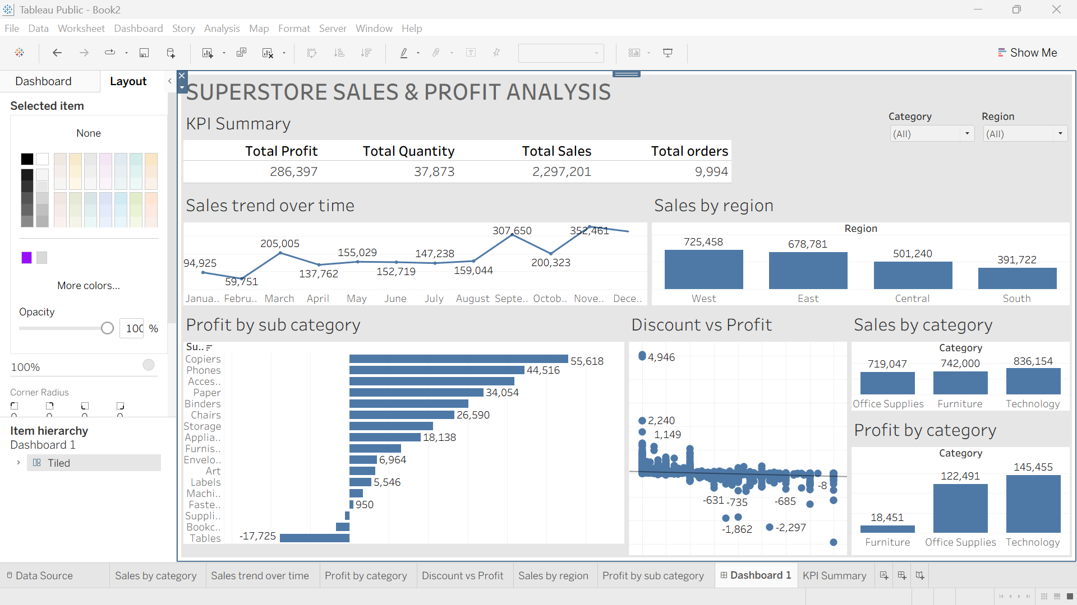
The dashboard combines KPI metrics, visualizations, and Region and Category filters into a single interactive view.

Key Findings
- Sales performance differs across product categories.
- Sales fluctuate across different time periods.
- Regional sales performance varies.
- Copiers are the highest-profit sub-category.
- Tables show the largest negative profit.
- Higher discounts are generally associated with lower profit.
- The interactive filters allow users to explore Region and Category performance.

Conclusion
The Superstore dataset was successfully analyzed using Tableau through Exploratory Data Analysis. The visualizations helped identify important patterns in sales, profit, categories, regions, sub-categories, and discounts. The final interactive dashboard provides a consolidated view of business performance and allows users to explore the data using filters.

